**Write a java program to write data into an hive table:**

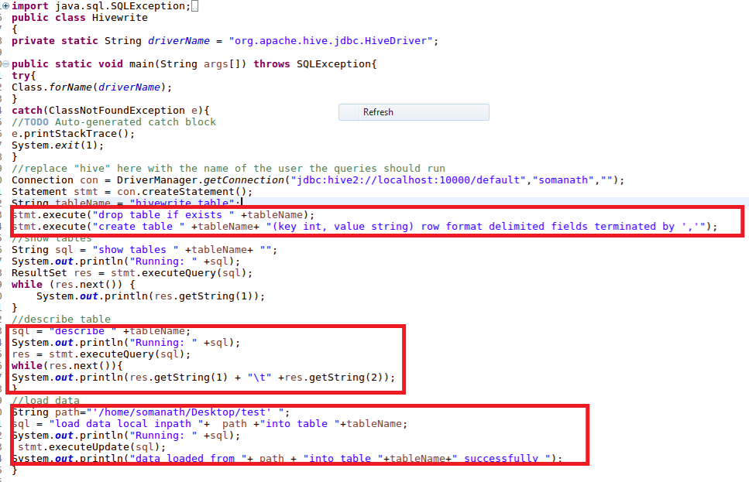

**Output:**

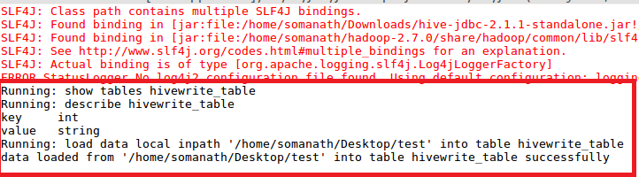

**Verifying that the table is created and data is loaded :**

